Motivation

To demonstrate how a (MySQL) relational database's tabular data that represents transactions/events can be queried for the occurrence of duplicative (PK) Account IDs associated with different geographic regions that happen within an impossible timeframe.

This phenomenon *could* be an indicative flag of fraudulent use of a credit card (as an example).



Design Overview | AppSchema

This example leverages a Java app – **AppSchema** – which generates SQL DDL statements that model transactions as SQL table rows in a table named events.

The DDL INSERT statements are generated, and are formulated to appear within a stored procedure.

The entire stored procedure (code) is manually pasted into a MySQL terminal.

The pasting of the DDL code is a one-time operation.

The stated purpose of this static DDL is to provide an affordance which repeatably "plants" a series of events/transactions into a known SQL table, as rows.

In aggregate, having a defined number of rows, within a temporal-bounded span, and knowing that the synthesized rows contain a (known and reported) number of duplicate **Account IDs** allows a repeatable dataset – to serve as testing material for down-stream logic/processing.

The **AppSchema** Java app need only be run once, or it can be rerun at will to get fresh timestamps, (synthesized) account holder names, and **Account IDs**.

NB If run several times, the **AppSchema** app will generate an identical dispersion/distribution of duplicate transaction/events (again in terms of the value of the respective rows' **Account IDs**).

However, you can configure the **AppSchema** app to vary frequency of the "collision"/duplication characteristics.

This variation of the frequency of occurrence of duplicates is accomplished via a seeding algorithm which consists of three (3) prime numbers that are applied to the first three transactions (themselves, synthesized by logic within the **AppSchema** app).

After you are satisfied with (convinced of) the correctness of the distribution logic inside the **AppSchema** app, you can "scale-up" the number of generated rows in the events table, and simultaneously widen/narrow, and/or shift, the sampling timespan.

This allows you to discover other patterns of the occurrence of duplicative transactions/events.

The synthesizing of timestamps accounts for "clock-slew" that is inherent in OS routines that do not leverage an atomic clock – this can/will produce non-unique results for the synthetic temporal values.

ref <https://en.wikipedia.org/wiki/Clock_skew#Harmful_skew>

We factorize-out this anomaly by sleeping awhile between timestamp construction calls.

Finally, the forensic discovery logic is contained in another, companion application named **AppCallable**.

Design Overview | AppCallable

This example leverages a second Java app – **AppCallable** – which uses a simple *MapReduce* algorithm to detect duplicative transactions occurring within a time-bound period, and persisted inside a SQL table named events.

The listing of suspected fraudulent occurrences (the payload) is reported directly to the **AppCallable** terminal, at runtime, in these formats: a. A raw string representation of a ConcurrentHashMap; b. Classic JSON; c. A JQL representation.

Additionally, the JSON payload is portrayed on a Chrome-based page.

The Chrome User-Agent is launched programmatically – but leveraging cURL, Newman, Postman, etc could be substituted for leveraging Chrome.



Processing Flow | Recipe Design Pattern | AppSchema, AppCallable

Two loosely-coupled Apps – AppSchema, AppCallable – together, model the processing described in the **Motivation** section. This cooperative approach to a workflow is an implementation of the Recipe Design Pattern.

1. STEP1

**Invoke AppSchema**

Generates DDL statements that deliberately reflect rows in the events SQL table that bear duplicate (PK) **Account IDs**.

This SQL data model creates the basis for another application – AppCallable – to detect the rows in the events table, which contain duplicate (PK) **Account IDs**.

The resultant SQL data model creates the basis for another application – AppCallable – to detect the rows in the events table, which contain duplicate Account IDs.

2. STEP2

Refresh the ßash Terminal that enables the Linux command that displays the contents of the /tmp/TALISMAN file. This command portrays the file that conveys the temporal boundaries of the events (contained in the events SQL table) to the consuming application.

tail -f TALISMAN

The other app is named AppCallable (it calls a MySQL stored procedure named whatever).

See STEP6.

3. STEP3

Paste generated DDL (STEP1) into the terminal hosting the MySQL client.

4. STEP4

Call the dataset stored procedure (generated in STEP1).

This call to the AppSchema stored procedure actually populates the events SQL table with current timestamps.

5. STEP5

Verify – Reconcile tail -f TALISMAN entries with timestamp column's values of the events table

6. STEP6

**Invoke AppCallable**

The logic within AppCallable stored procedure is bounded by two values found in the /tmp/TALISMAN file.

7. STEP7

**Reconcile Logic**

To validate the processing logic, compare the occurrence of (duplicate) input data points (rows in the SQL events table) with the detected output data points.

8. STEP8

Optional – Pseudo-randomize the frequency of the duplicate entries inserted into the events SQL table.

In-Situ | AppCallable (as processing transpires)

The information contained within the SQL table named events is created/synthesized in a Store Procedure named whatever, created by the **AppSchema** app.

DDL-SPECIFIED

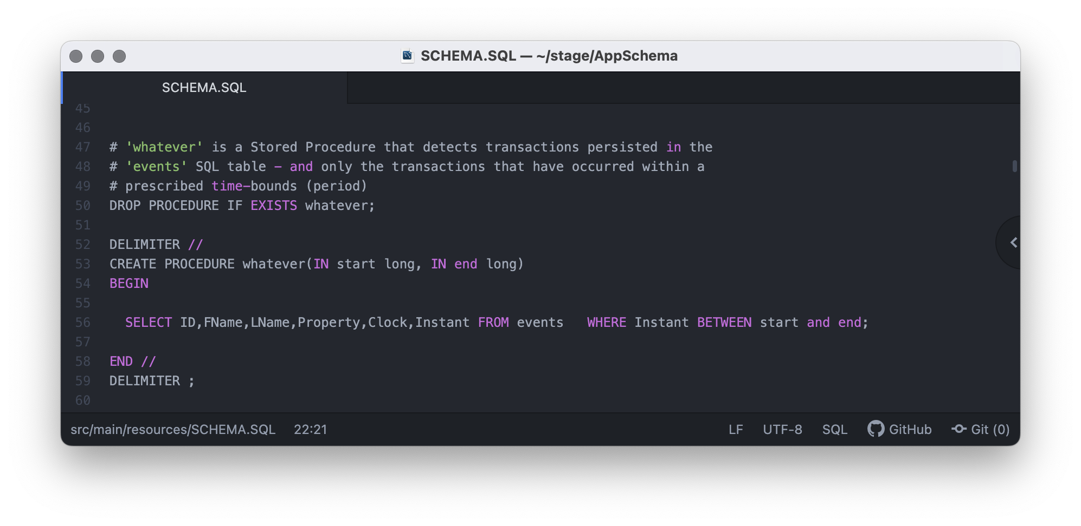

REIFIED-AS

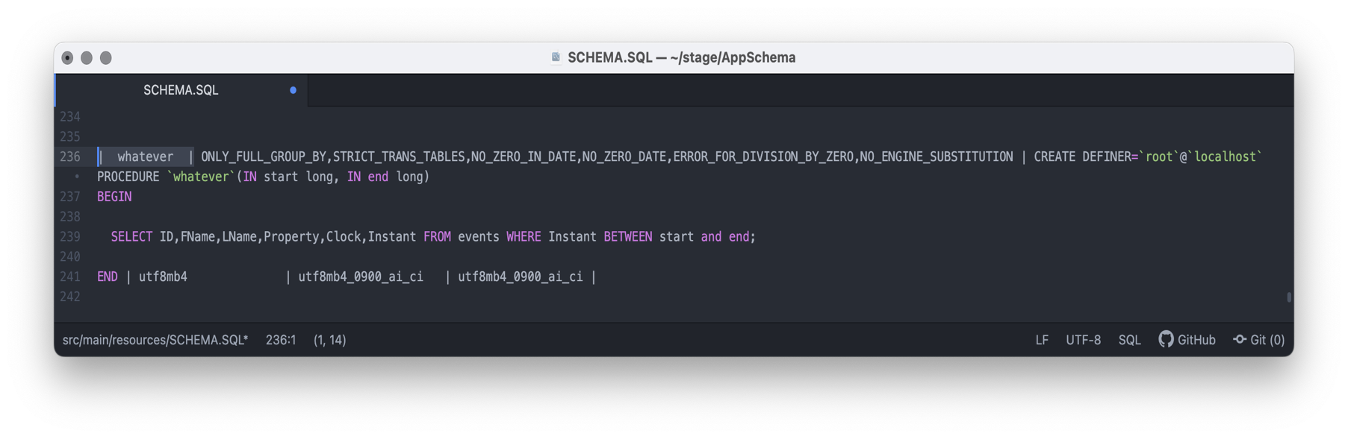

CONTINUES

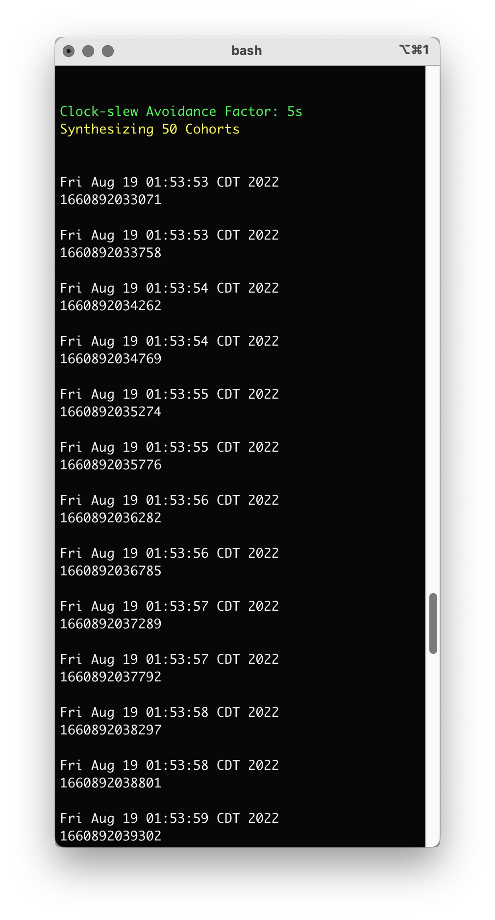

The entries in yellow flag date representation of the intentionally-generated

duplicate entries in terms of their Account IDs | 1/5.

CONTINUES

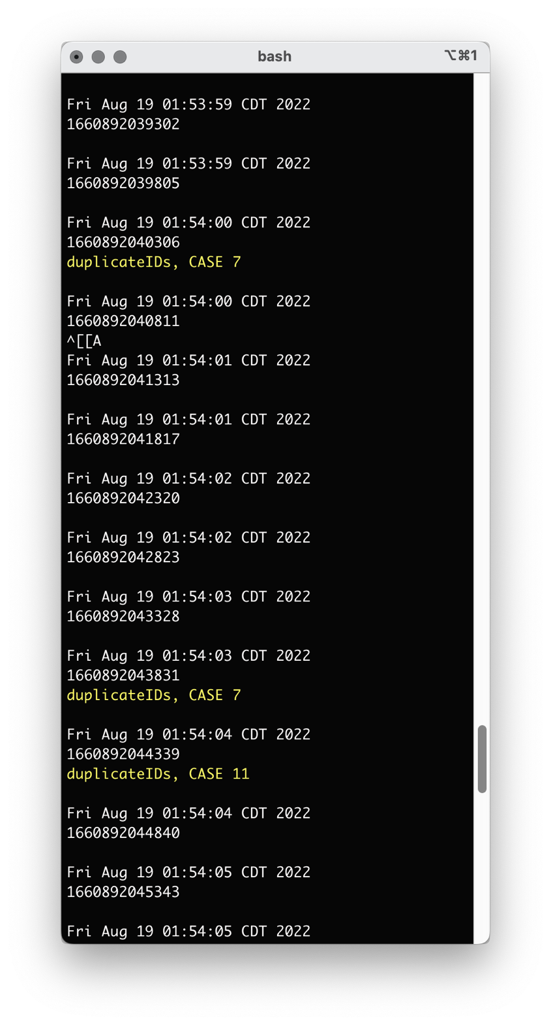

The entries in yellow flag date representation of the intentionally-generated

duplicate entries in terms of their Account IDs | 2/5.

CONTINUES

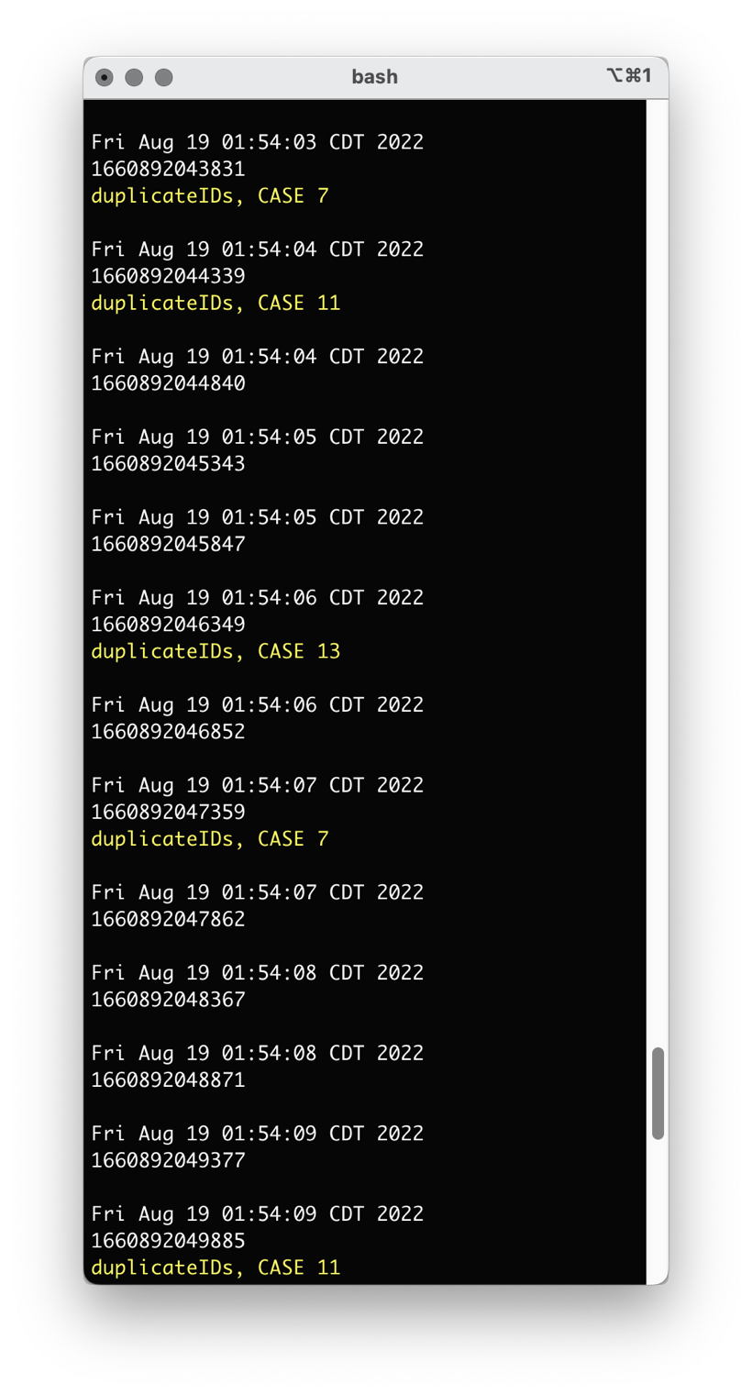

The entries in yellow flag date representation of the intentionally-generated

duplicate entries in terms of their Account IDs | 3/5.

CONTINUES

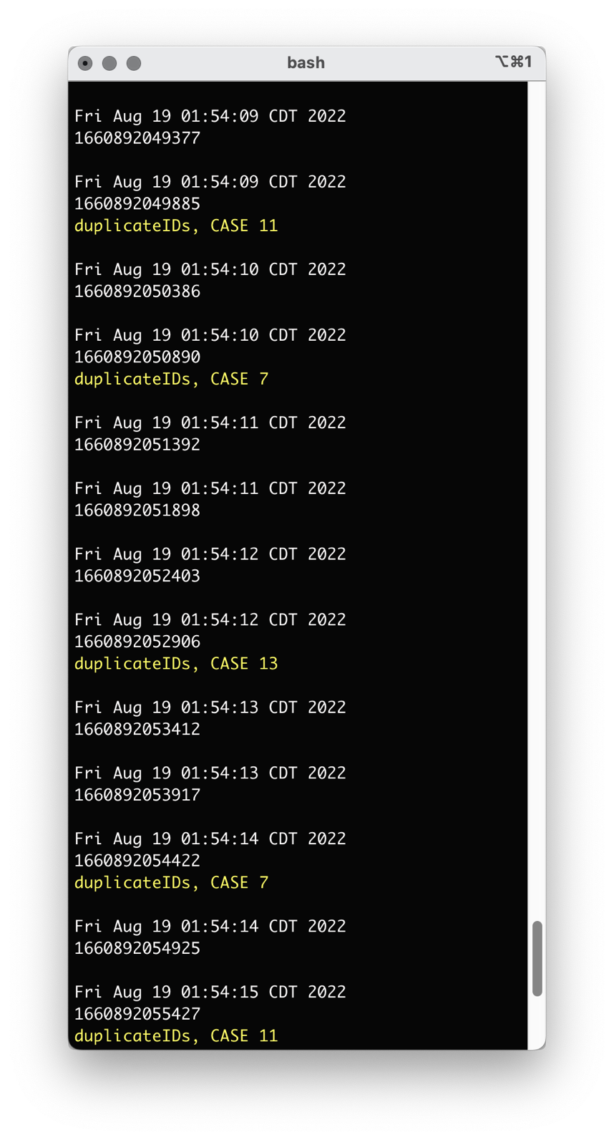

The entries in yellow flag date representation of the intentionally-generated

duplicate entries in terms of their Account IDs | 4/5.

CONTINUES

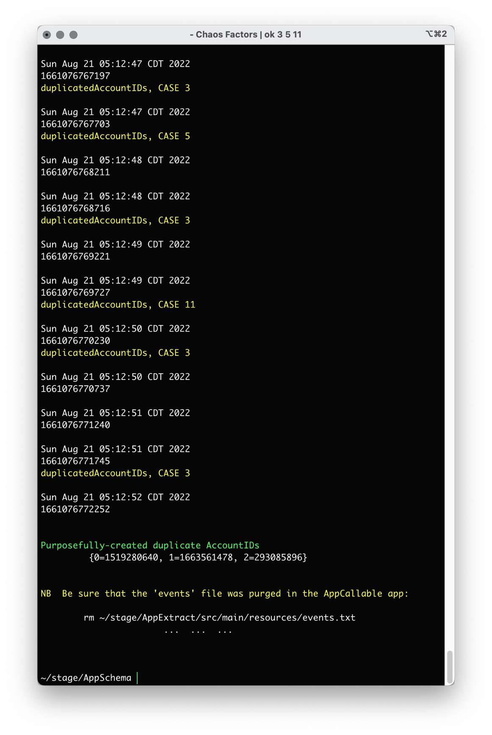

The entries in yellow flag date representation of the intentionally-generated

duplicate entries in terms of their Account IDs | 5/5.

CONTINUES

The green-labeled hash map in the previous screen shot shows as its **Key**, the tally of a cluster deliberately-generated duplicate rows in the events SQL table [qty: 3].

For the **Value** (of the hash map) the associated **AccountID** which appears in those rows (in the events SQL table) is depicted/used. This is not the timestamp of the row(s) in question.

These are the rows that are represented in yellow in the preceding screenshots.



Metadata | Flat-file Serves-as Inter-process Exchange Mechanism

The entries in a flat file TALISMAN – located in the canonical folder /tmp/ – are generated by the **AppSchema** application.

They convey *SUGGESTED* time bounds [BEGIN, END] for guidance as to an "*inspection window*" for the logic contained within the downstream application: **AppCallable**.

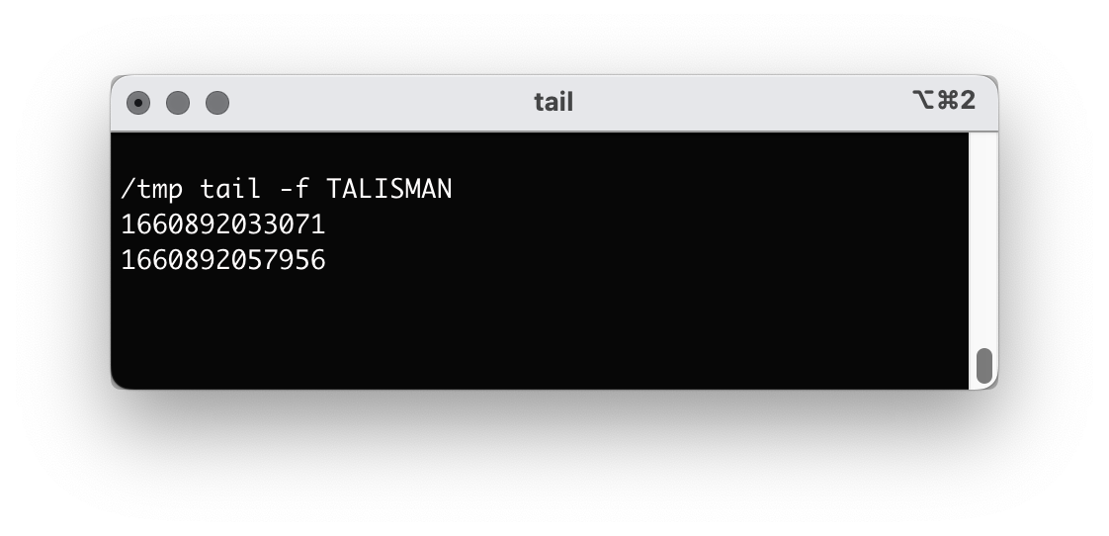

After the DDL/DML is generated by the AppSchema (Java app), the temporal begin/end **date value boundaries** for the entirety of the generated events SQL table rows are persisted to a flat file:

/tmp/TALISMAN

The two values in the /tmp/TALISMAN file correspond to the values found in the *events.INSTANT* (date) column.

The *first line* in the /tmp/TALISMAN file represents the value of the *events.INSTANT* column in the events table's *FIRST ROW*.

The *second line* in the /tmp/TALISMAN file represents the value of the *events.INSTANT* column in the events table's *LAST ROW*.

This is shown in the two screen shots on the next two pages.

NB The innate behavior of the 'nux tail -f utility/filter stipulates that a new Terminal

must be opened whenever the contents of the file being observed changes.

CONTINUES

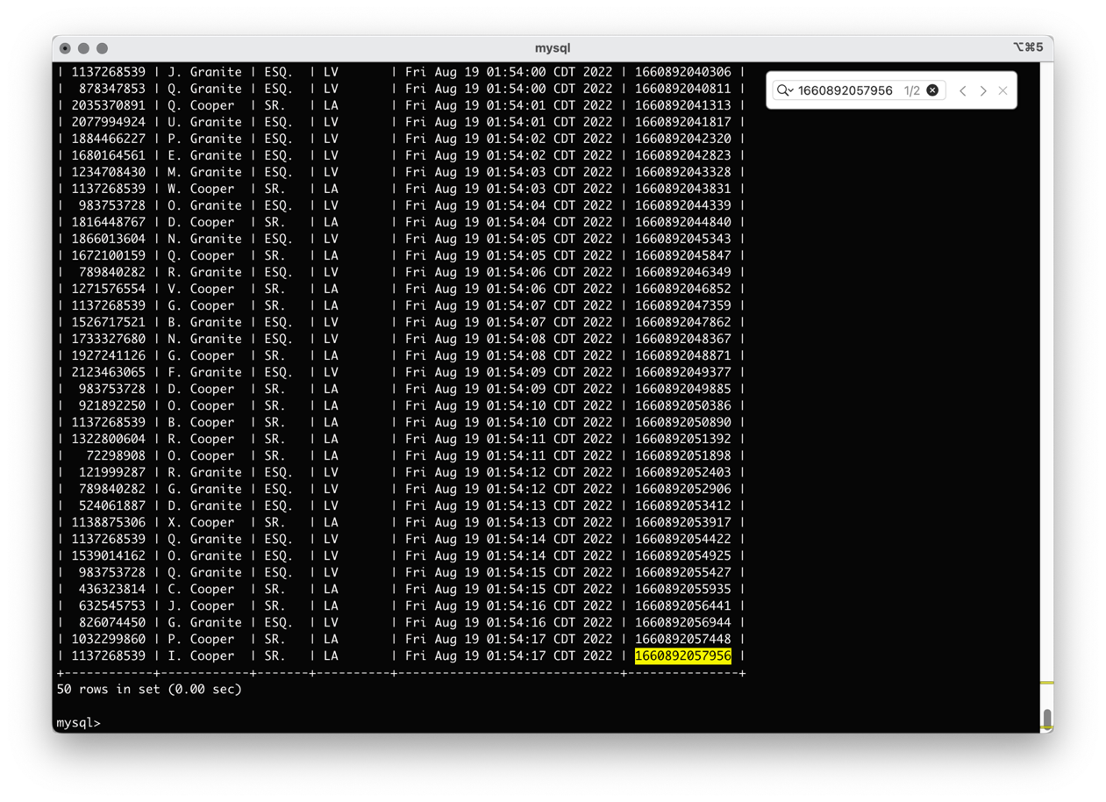

CONTINUES

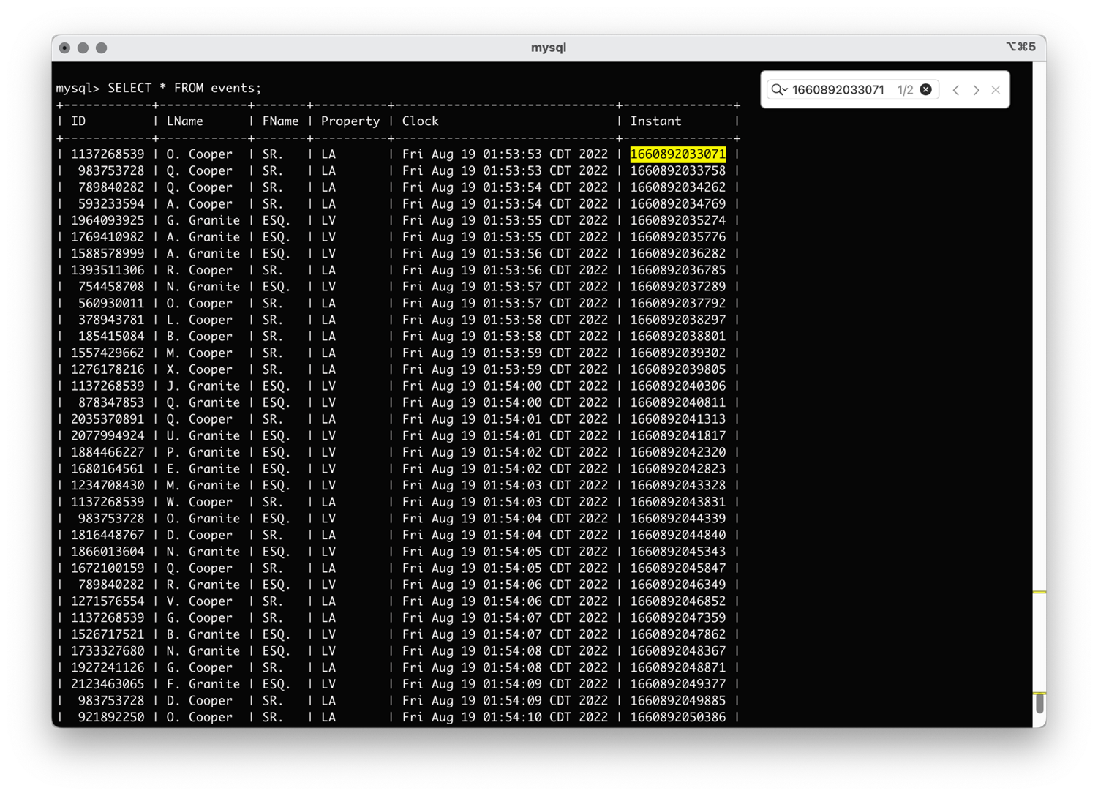



Metadata | Specifying the Degree of Duplicate AccountIDs (Chaos Factor)

The *DEFAULT* time-bounds value(s) – 7, 13, 17 – can be overridden on the command line:

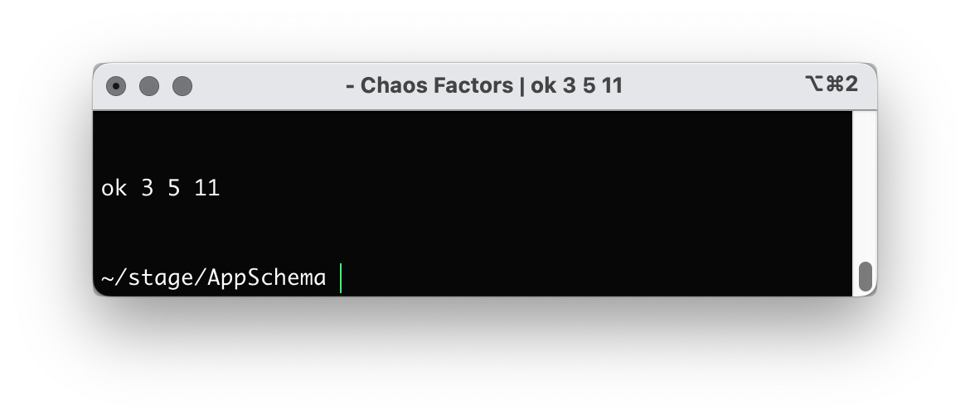

The actual values of the chaos modes appear on the Terminal/console at the invocation of the **AppSchema** app:

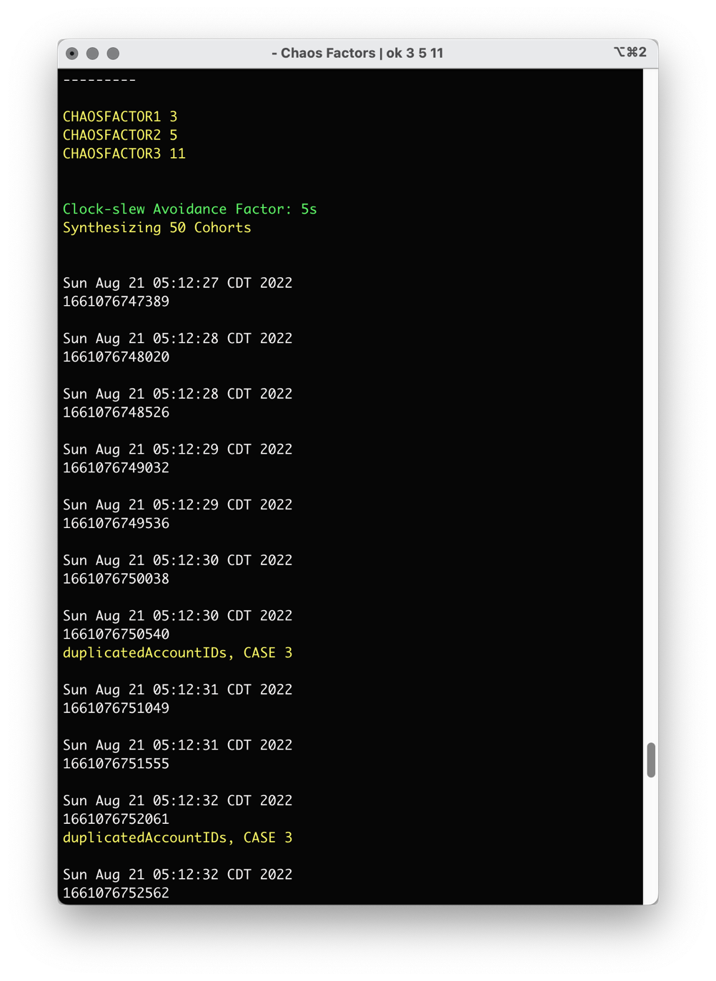

In-Situ | AppCallable (as processing transpires)

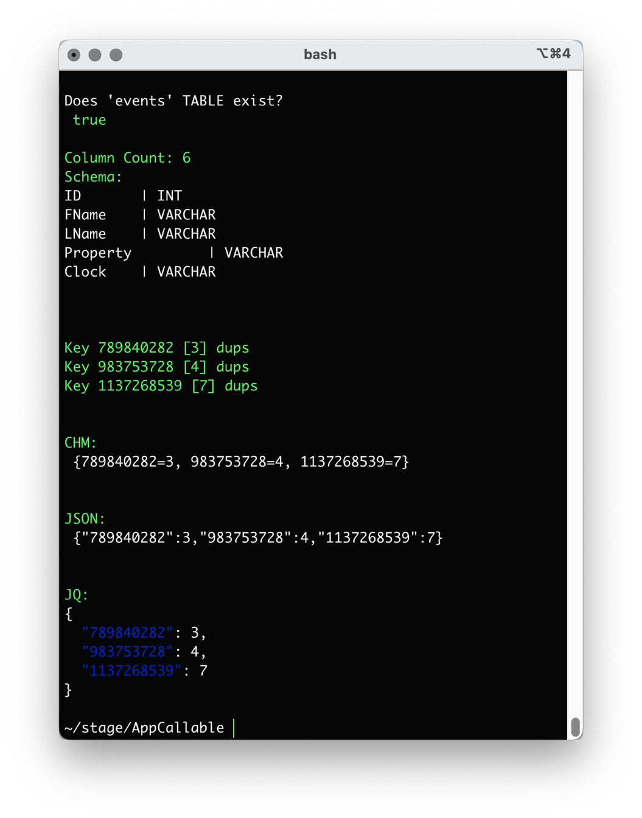

A comparison of the content of the green listing above [qty: 3] with the green-labeled hash map in the screen shot on page 6, you can see that they match both in cardinality and in their respective, intrinsic values.

The derivation is a result of a simple MapReduce operation (no, not streams-based).

The screen shot on the next page shows the same indicative data as JSON, in Chrome.

CONTINUES

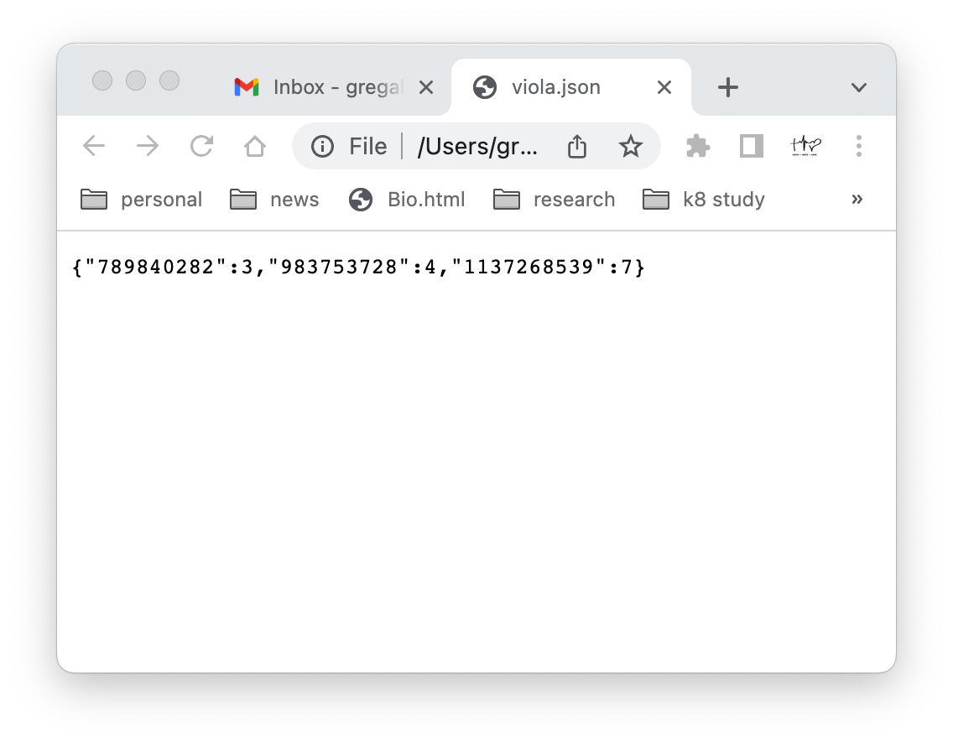

CONTINUES

The first part of the **AppCallable** app's core processing logic is invoked via a Stored Procedure named dataset – which accesses transaction information contained in the SQL table named events.

Invocation of the **AppCallable** app is simple – a CLI call to a ßash script named ok

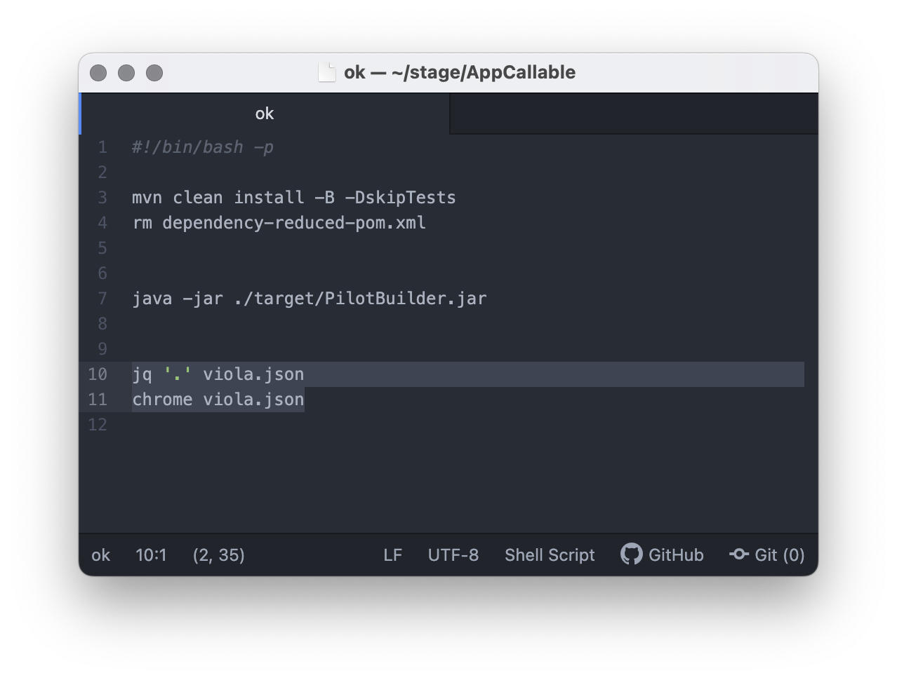

To get a fuller portrayal of the (suspect) data points for the **Account IDs**, a kind of join can be done.

This conceptual join can be had as a SQL-based query, or as a lookup/hookup into the resources/MODEL.SQL flat-file that is generated by the AppCallable (Java app), the next page shows an example of the file.

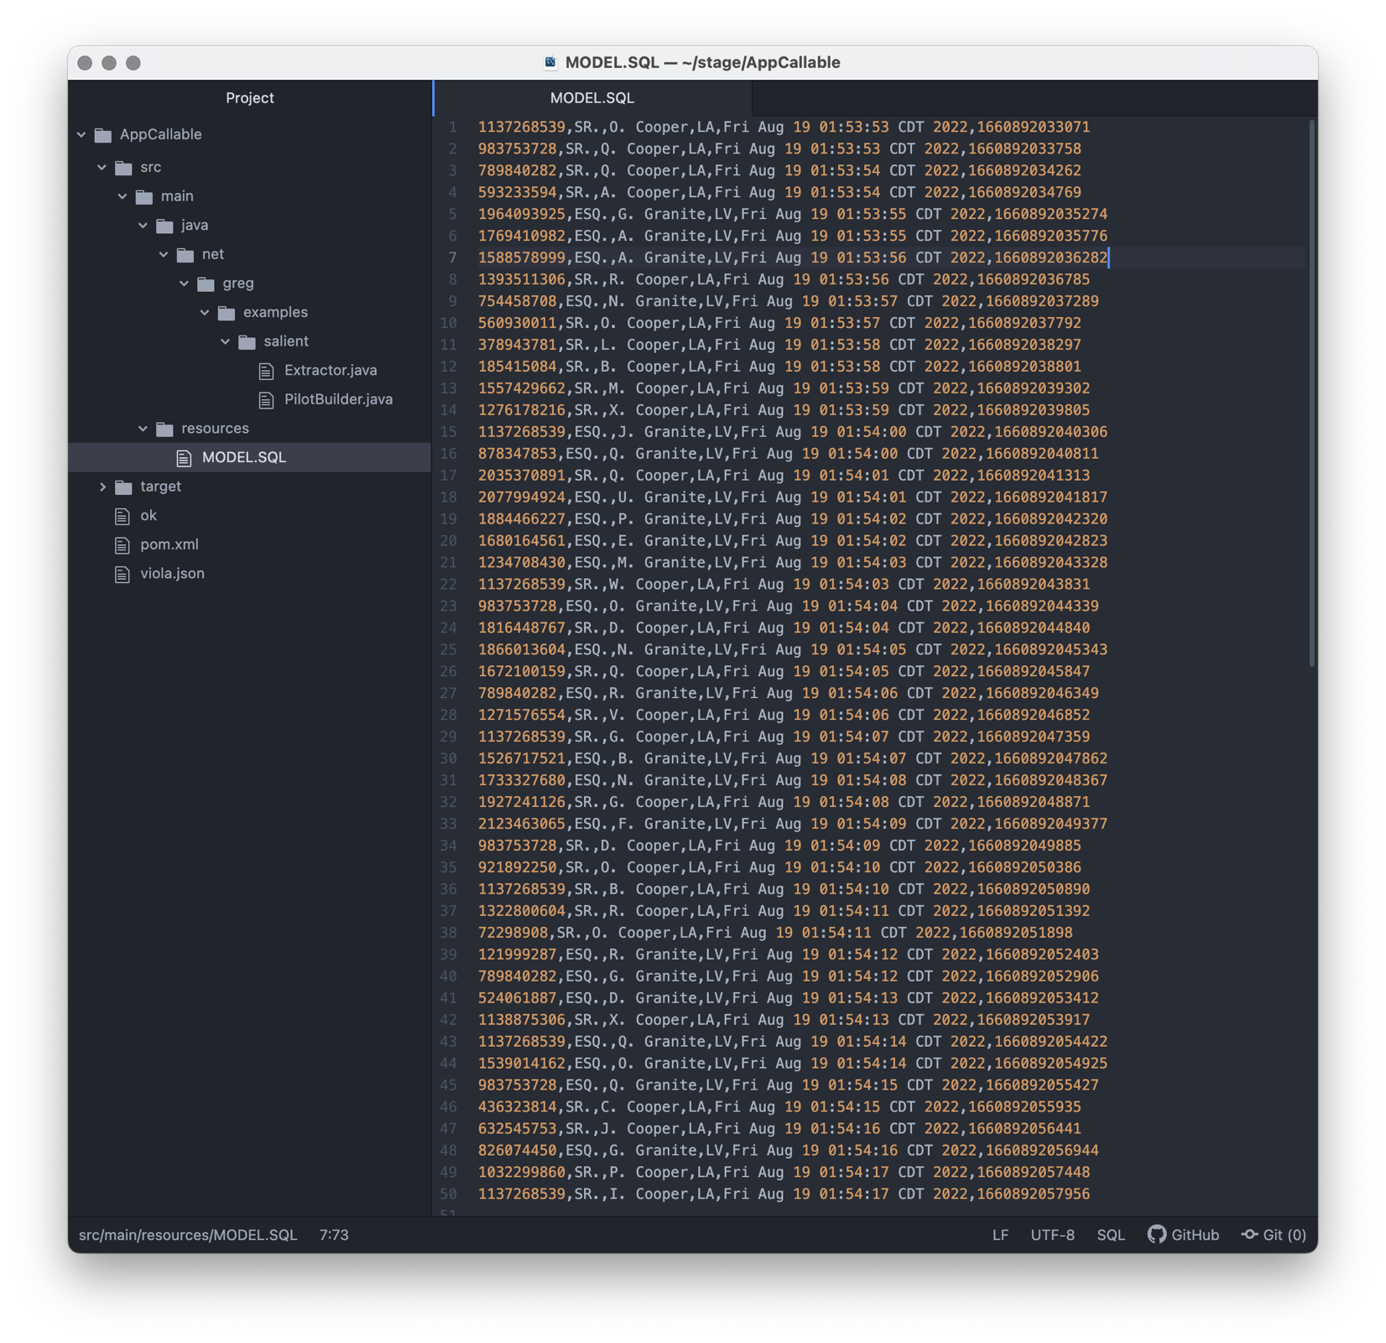

FINAL